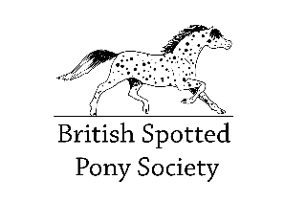BRITISH SPOTTED PONY SOCIETY

PASSPORT APPLICATION FORM

INSTRUCTIONS:
Identification of the animal.
If you are going to complete the markings chart yourself this must be done before the vet implants the microchip. Make sure that you have found all the whorls and that you have marked them on the chart with a clear black x. White markings should be marked and hatched in red. If your vet is going to do this for you they should use the same method for recording the markings.
If less than three whorls are found then the vet should draw the chestnuts.
The vet should then implant the microchip, mark the site on the chart with an ‘m’ and sign/stamp/date the form to confirm that they have implanted the microchip into the animal described in the charts. A bar code of the microchip should be stuck in the place indicated.
Fast track service: if you require a passport by a specific date you can request a ‘fast track service’ for an additional fee of £10 per passport. This service is available by request only. Please contact the registrar for further details.

Please complete the rest of the form carefully and send to –
Rosie Perry-Evans, BSpPS Registrar
Bramley Cottage, Cheriton Bishop, Exeter, Devon, EX6 6HD

Please ensure that you have sent:
-The completed form
-A covering certificate if you do not own the sire
-If either the sire or dam is registered with another society please enclose a photocopy of their registration.
-Two good photographs of each side (4 in total): a passport photo printing service is available for £2.50 per animal. Post your passport application to the registrar and email the accompanying photos to – info@britishspottedponysociety.co.uk
-The fee £20.00 Members, £40 Non-Members. Late/Duplicate/replacement passports £40 Members, £60 Non Members. Passport photo printing service £2.50 per animal.

Payment details…Bank transfer is preferable (please use ponies name as reference)
Bank: Natwest
Name: British Spotted Pony Society Ltd
Account No. 63213893
Sort Code: 60-08-30
* Please make cheques/postal orders payable to: British Spotted Pony Society Ltd.

The BSPPS is a private company, number 3507553, limited by guarantee and registered in England.
Registered Office: 92 Main Street, Halton Village, Runcorn, Cheshire, WA7 2AX. Charity 1069437
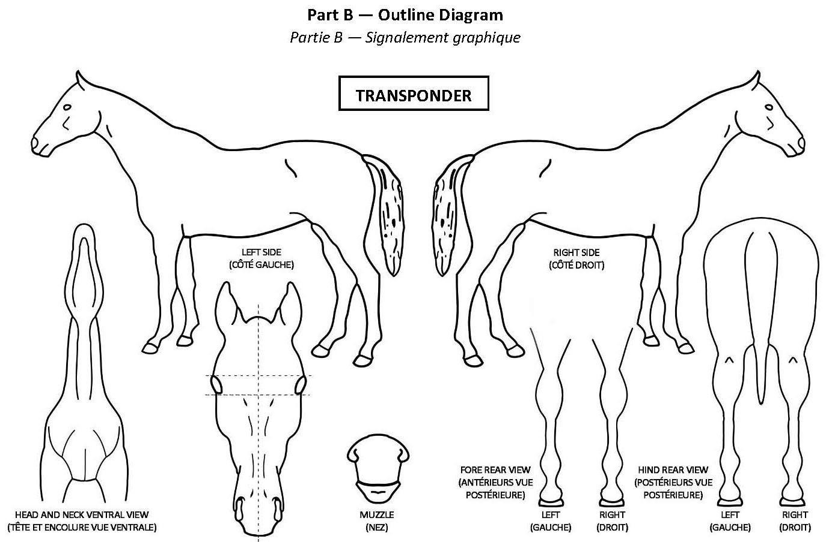

I certify that the markings are a true representation of the equine presented and that I have implanted a microchip

Date…..………………… Signature……………………………………... Stamp
If a previously implanted microchip has been found please write the
number here……………………………………………. +

Colour
Please note whorls and markings on the above chart, and enter description below
Head Markings

Nearside foreleg
Hoof
Offside foreleg
Hoof
Nearside hindleg
Hoof
Offside hindleg
Hoof

Body

Name and signature of person recording this description
Capacity (i.e. Breeder)
I hereby apply to the BSpPS for a passport for my: Colt…….. Filly…….. Mare…….. Gelding………

Name of Pony Registered Prefix County and Country
Date of birth Adult Height
Colour at birth
Does the animal have white sclera ? Parti-coloured skin ?

Blue eyes ? Scars ?
Microchip Number
Yes No
Yes No
Yes No Left Right
Yes No

Pedigree

SIRE

Name

Number Height

Colour

Grandsire Name

Number Height

Colour

Granddam Name

Number Height

Colour

DAM

Name

Number Height

Colour
Grandsire Name

Number Height

Colour

Granddam Name

Number Height

Colour

Owner Name
Address

I hereby certify that the information contained herein is correct to the best of my belief.

Signed Date
Member Number
Contact number/email
Please tick here if you do not wish these details to appear in the Stud Book

Breeder Name
Address

I hereby certify that I am the breeder of this pony, that the dam was recorded under my ownership at the time of foaling and that the pedigree is correct.
Signed Date

Contact number/email
Please tick here if you do not wish these details to appear in the Stud Book

Service Certificate
If the Sire is owned by the breeder, please sign here in lieu of a service certificate. Signed Date

If the sire is not owned by the breeder, then a service certificate signed by the stallion owner at the time of covering must be included.

