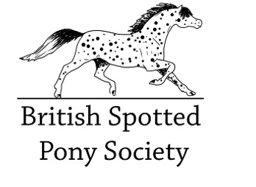
BSpPS Lost/Stolen Passport Declaration

Name of animal....
Male/Female/Gelding.....................Date of birth........................... UELN.......................................................................
(or Registration number)
Microchip number...................................................

I declare that the passport belonging to the above animal has been
Lost…..
Stolen…………….. Crime number………………..
I understand that it is a criminal offence to hold two passports for the same animal. If the original passport is found/recovered I will return both passports in order that one may be invalidated.
Name of owner...................................................................... Address........................................................................................
.....................................................................................................
.....................................................................................................
Post code......................................Signature.................................

The fee for a replacement/duplicate passport is £40 for members, £60 for non members.

Please send this form with passport application, photographs & fee to:
Rosie Perry-Evans, BSpPS Registrar
Bramley Cottage, Cheriton Bishop, Exeter, Devon, EX6 6HD

Charity 1069437 Registered Office: 92 Main Street, Halton Village, Runcorn, Cheshire, WA7 2AX. The BSpPS is a private company, No 3507553, limited by guarantee and registered in England.

